- 创建表(acces,sql)
- 查询记录
- 插入记录
- 删除记录
- 在datagrid中显示
- 调用存储过程
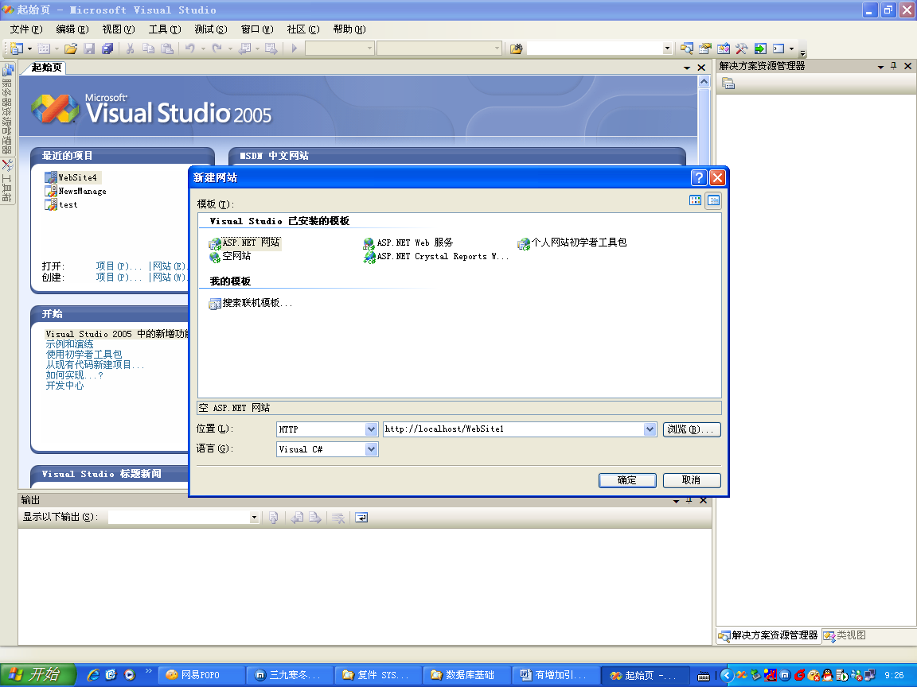
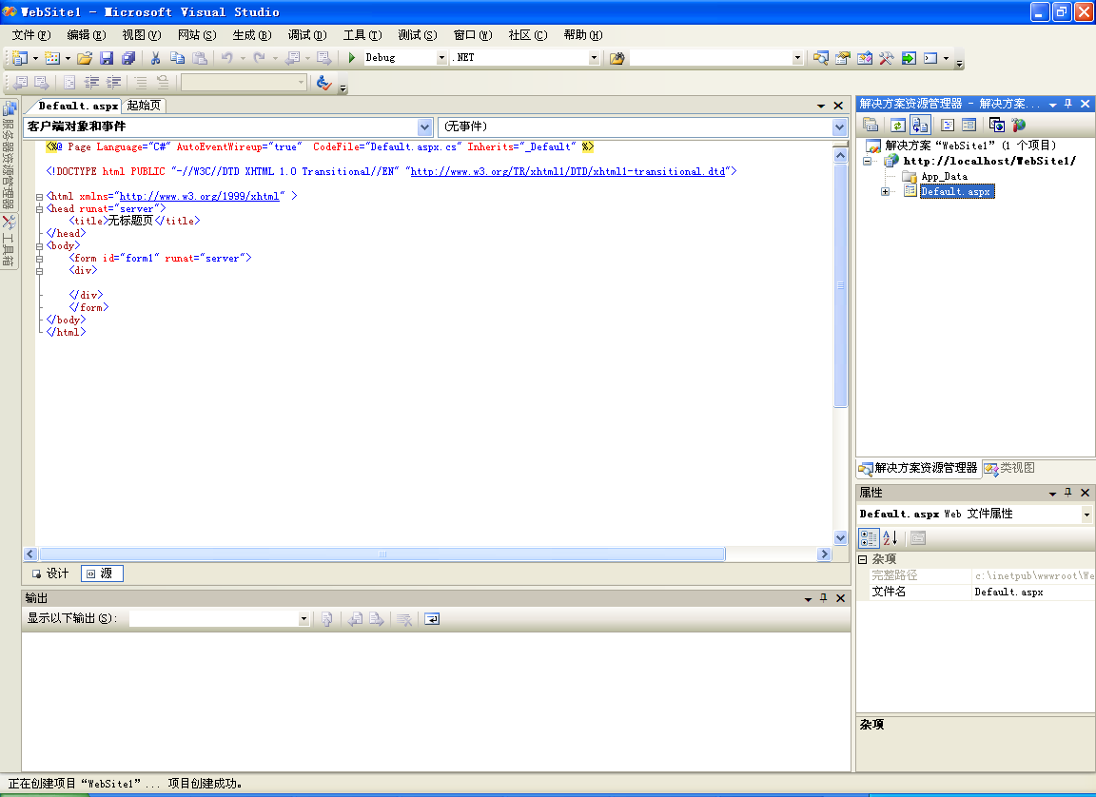
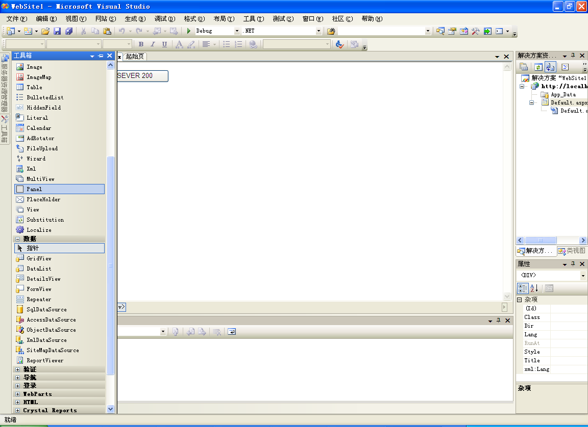
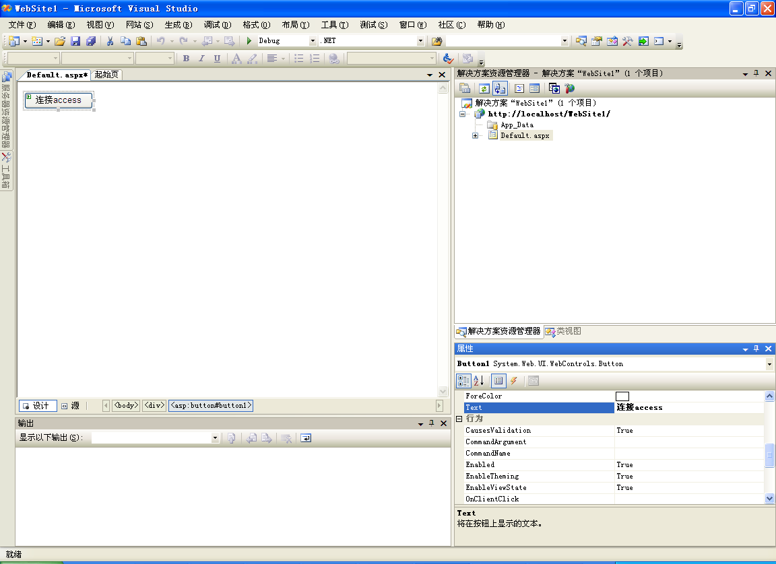
下面代码是连接sql server 2000的。
下面是在access中查询记录
using System;
using System.Data;
using System.Data.OleDb;
using System.Configuration;
using System.Web;
using System.Web.Security;
using System.Web.UI;
using System.Web.UI.WebControls;
using System.Web.UI.WebControls.WebParts;
using System.Web.UI.HtmlControls;

public partial class _Default : System.Web.UI.Page
{
protected void Page_Load(object sender, EventArgs e)
{

}
protected void Button1_Click(object sender, EventArgs e)
{
OleDbConnection myConnection = new OleDbConnection("Provider=Microsoft.Jet.OLEDB.4.0; Data Source=c:\\stu.mdb");
myConnection.Open();
string mySelectText = "select couid, couname from course";
OleDbCommand objCmd = new OleDbCommand(mySelectText, myConnection);
OleDbDataReader objRd = objCmd.ExecuteReader();
while (objRd.Read())
{ Response.Write(objRd.GetString(1) + "<br>"); }
myConnection.Close();

}
}

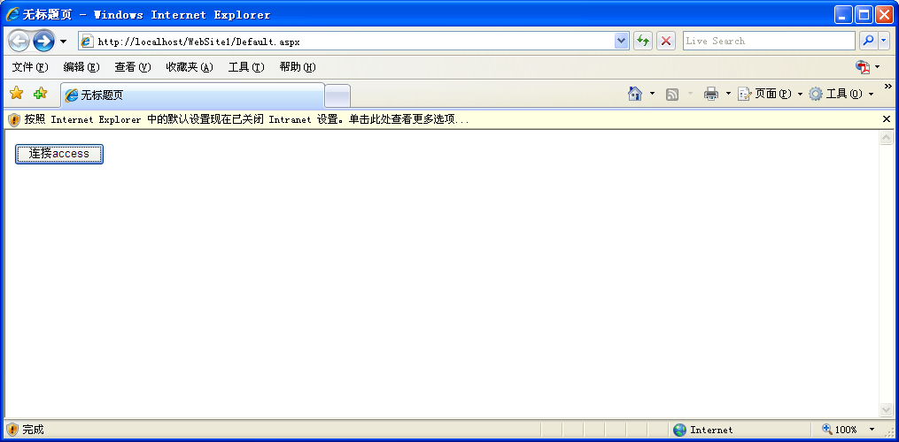

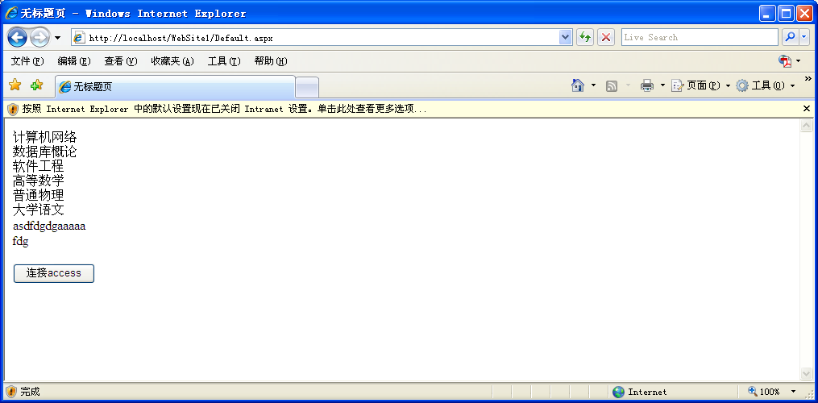

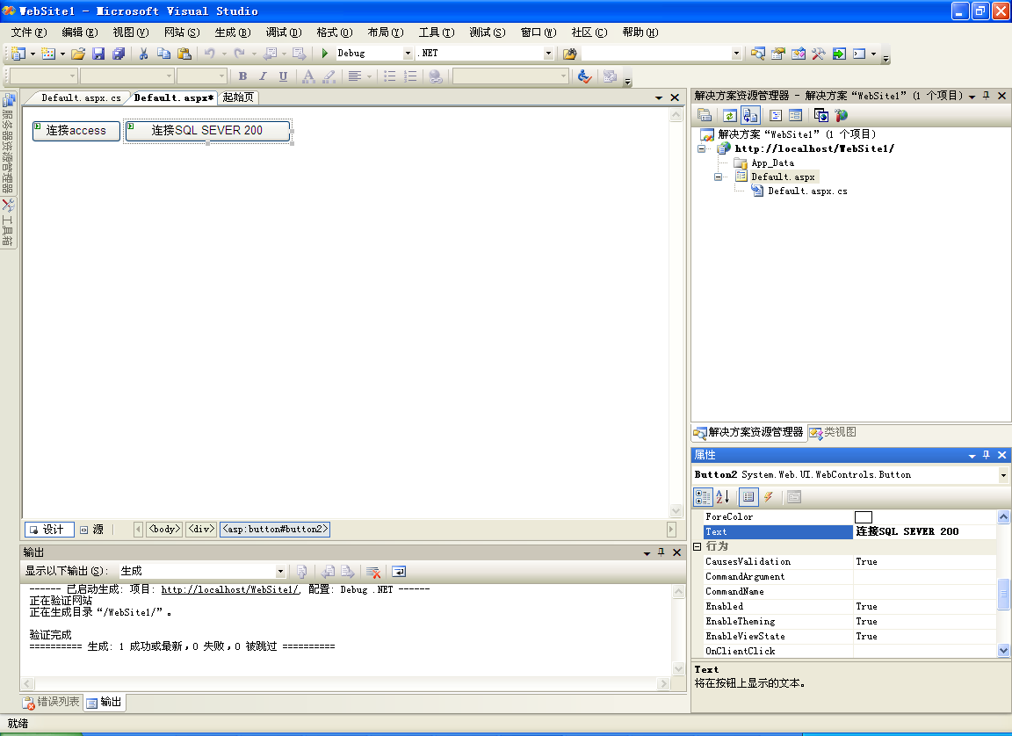
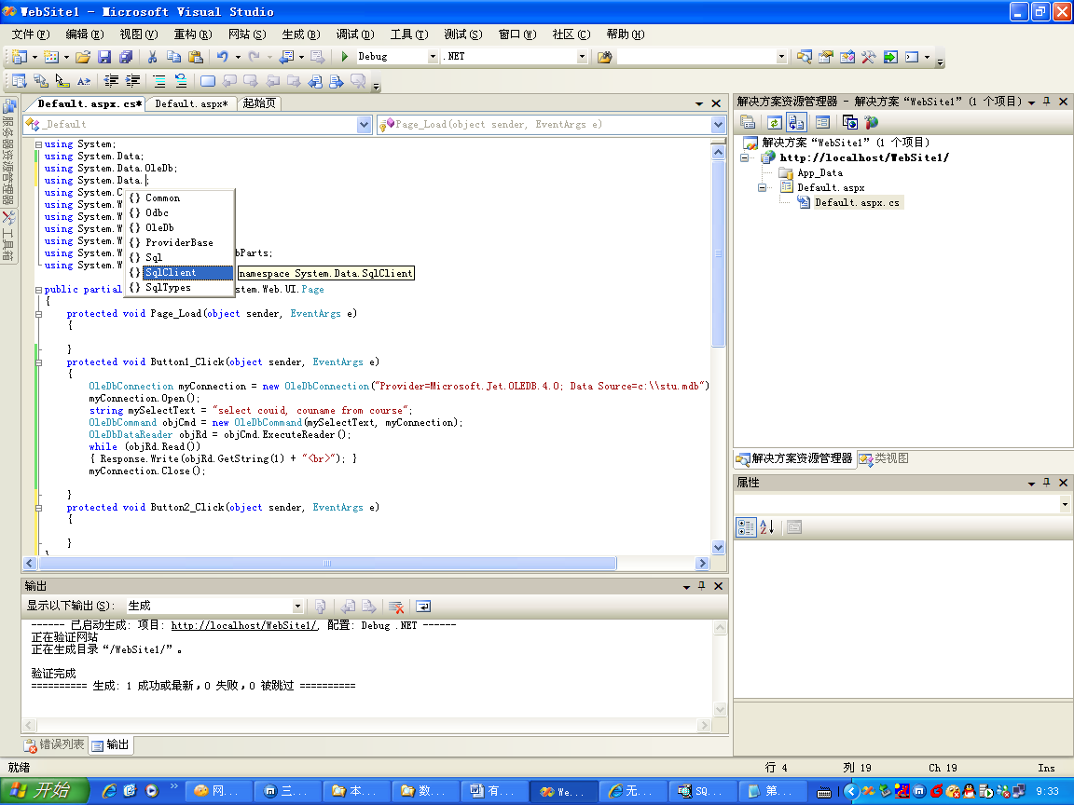
下面是在SQL２０００中查询记录
private void Button2_Click(object sender, System.EventArgs e)
{string SQLConnectionString="Password=lafposthe;Persist Security Info=True;User ID=sa;Initial Catalog=master;Data Source=127.0.0.1";
SqlConnection objConnection = new SqlConnection(SQLConnectionString);
string strSql = "select sno,sname from student";
objConnection.Open();
SqlCommand cmd = new SqlCommand(strSql, objConnection);
SqlDataReader objRd =cmd.ExecuteReader();
while(objRd.Read())
{
Response.Write(objRd.GetString(1)+"<br>");
}
objConnection.Close();
}
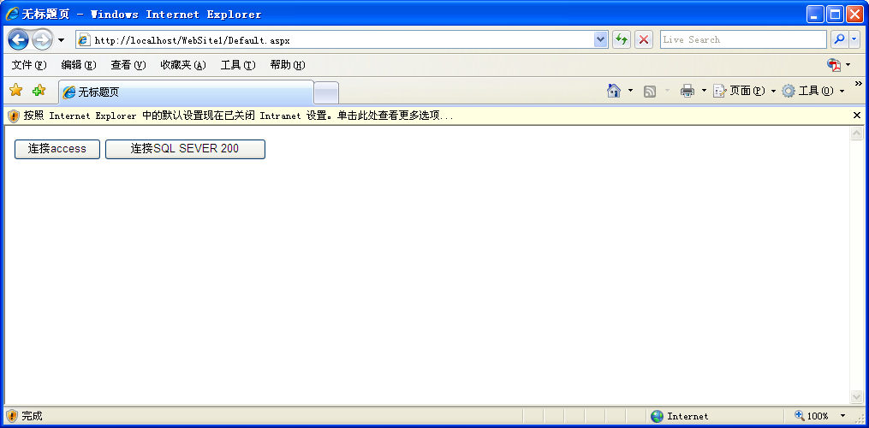

下面是调用datagrid查询数据
private void Button1_Click(object sender, System.EventArgs e)
{

string strConnection = ConfigurationSettings.AppSettings["SQLConnectionString"];
SqlConnection objConnection = new SqlConnection(strConnection);
string strSql ="select sname from student";
DataSet objDataSet = new DataSet();
SqlDataAdapter objDataAdapter = new SqlDataAdapter(strSql, objConnection);
objDataAdapter.Fill(objDataSet, "student");
DataView objDataView = new DataView(objDataSet.Tables["student"]);
DataGrid1.DataSource = objDataView;
DataGrid1.DataBind();
}
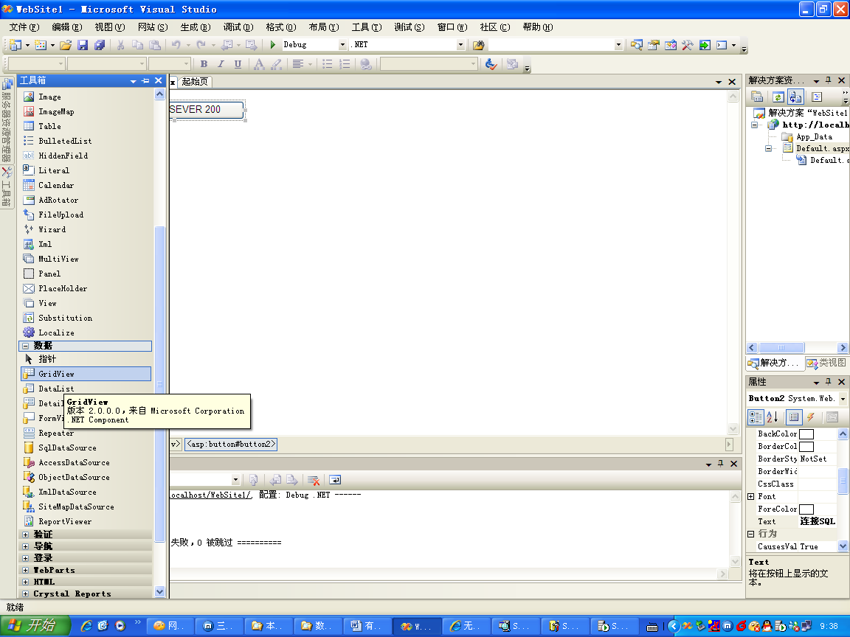

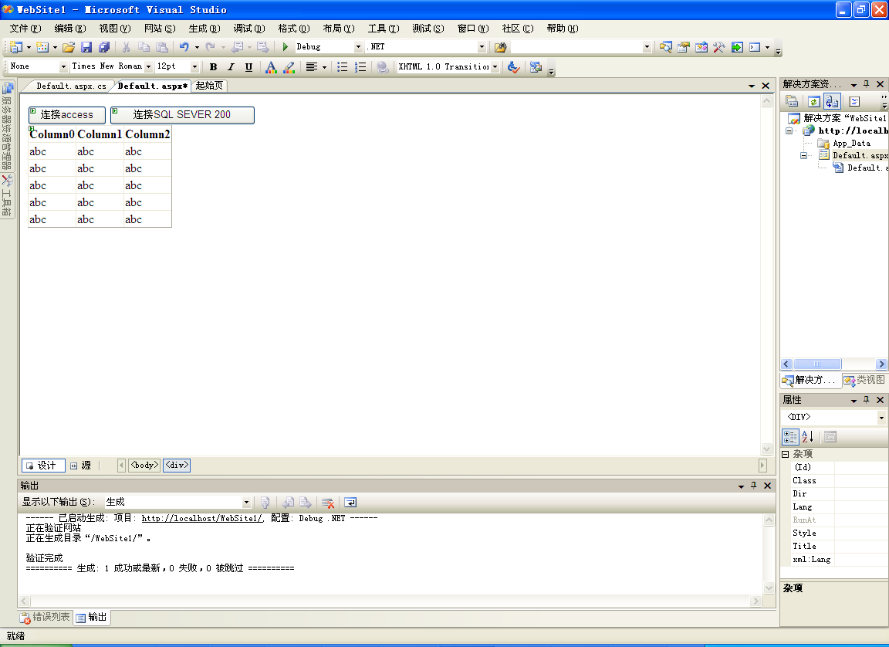

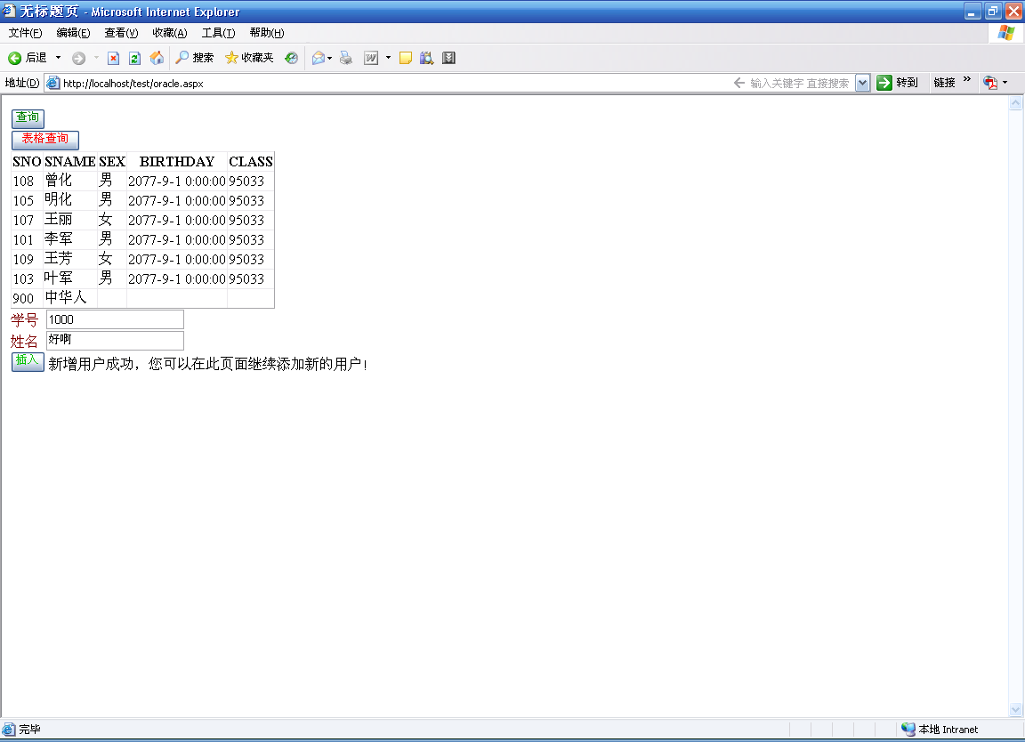
3.4.4调用存储过程

private void statistic()
{string strConnection = ConfigurationSettings.AppSettings["SQLConnectionString"];
SqlConnection objConnection = new SqlConnection(strConnection);
objCmd = new SqlCommand("branch_stat", objConnection);
objCmd.CommandType = CommandType.StoredProcedure;
objCmd.ExecuteNonQuery();
objConnection.Close();}

下面是创建存储过程
drop trigger dletestudent
go
create trigger dletestudent on student
for delete
as
declare
@counter int
select @counter=count(*) from score where sno in(SELECT sno FROM deleted )

if(@counter>0)
begin
rollback
end
go

delete from student where sno=108
select * from student

drop proc changeteacher
go

CREATE proc changeteacher (@tno1 int)

AS
begin
declare @counter int
declare @returnvalue int
set @returnvalue=0
select @counter=count(*) from teacher where tno=@tno1
if(@counter>0)

BEGIN
set @returnvalue=1
update teacher set proff='tno1' where tno=@tno1

end

return @returnvalue
end
go

EXECUTE changeteacher 804

插入记录：
private void btnOK_Click(object sender, System.EventArgs e)
{
string strConnection = ConfigurationSettings.AppSettings["SQLConnectionString"];
SqlConnection objConnection = new SqlConnection(strConnection);
try
{
objConnection.Open();
string temp = UserName.Text;
string temp1 = UserName.Text.ToString();
string user_name=UserName.Text.Trim();
string password=Password.Text.Trim();
string cfmpwd = CfmPwd.Text.Trim();
string chinese_name=RealName.Text.Trim();
string table_name="user_fl";
string user_type=UserType.SelectedItem.Value;
string user_desc = UserDesc.Text;
if (cfmpwd.Equals(password))
string strSql = "insert into user_fl(user_name, password, chinese_name, table_name, user_type, user_desc, " + "create_date, out_date, if_use, id_number, user_bank) values('"+user_name+"', '"+password+"', '" + chinese_name +"', '"+table_name+"','" +user_type+"','"+user_desc+"',getdate(), '2005-01-01','yes',0,'')";
SqlCommand cmd=new SqlCommand(strSql,objConnection);
cmd.ExecuteNonQuery();
prompt.Text = "新增用户成功，您可以在此页面继续添加新的用户！";

}
else
{
prompt.Text = "您两次输入的密码不相同，请重新输入！";

}
}
catch (Exception objE)
{
prompt.Text = objE.Message;//"新增用户失败！";
}
finally
{
objConnection.Close();
}
}

create table student(sno int,sname char(12),sex char(4),birthday datetime,class char(10) )
go
insert into student values(108,'曾化','男','77/09/01','95033');
insert into student values(105,'明化','男','77/09/01','95033');
insert into student values(107,'王丽','女','77/09/01','95033');
insert into student values(101,'李军','男','77/09/01','95033');
insert into student values(109,'王芳','女','77/09/01','95033');
insert into student values(103,'叶军','男','77/09/01','95033');
go
下面代码是连接oracle的。
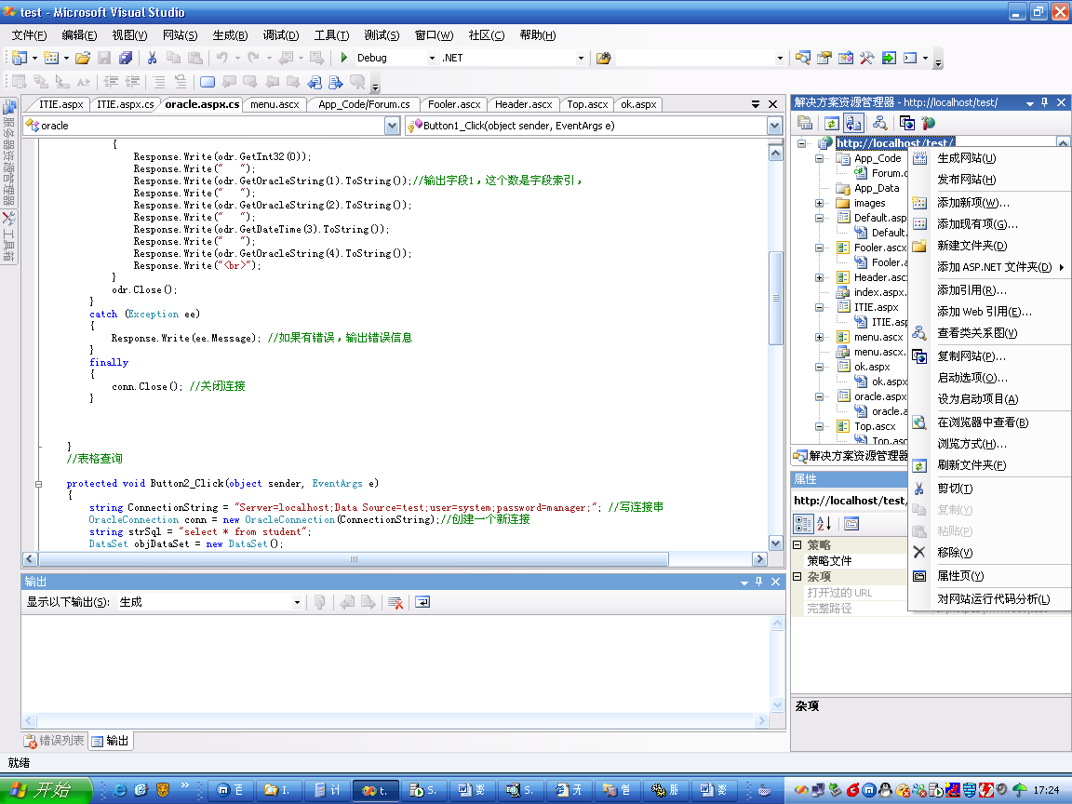

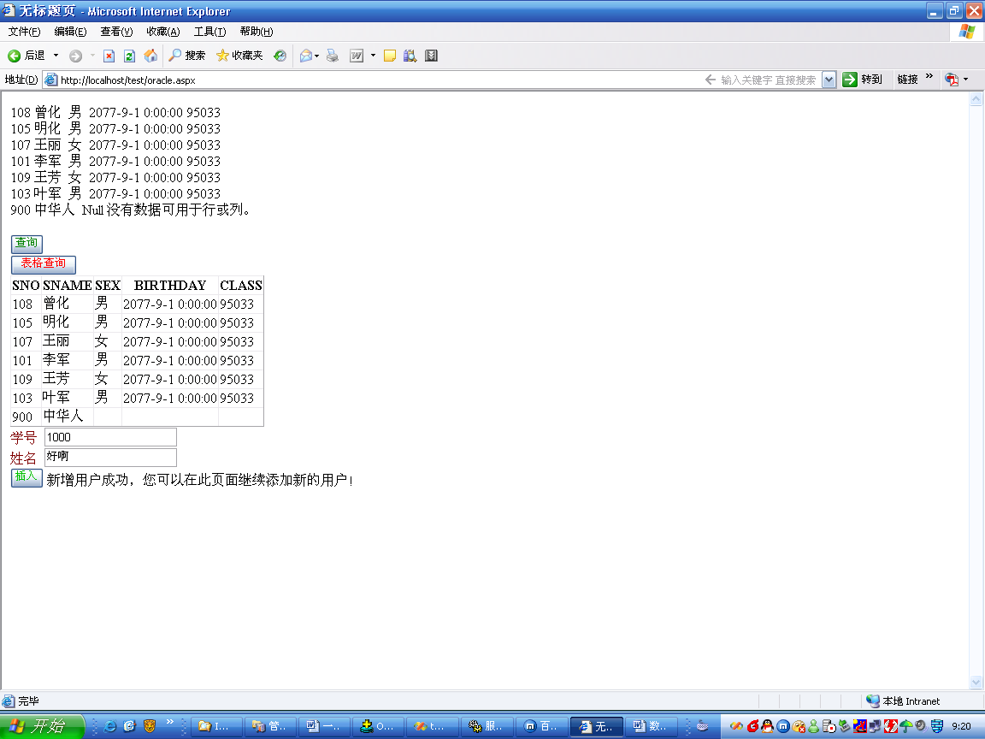

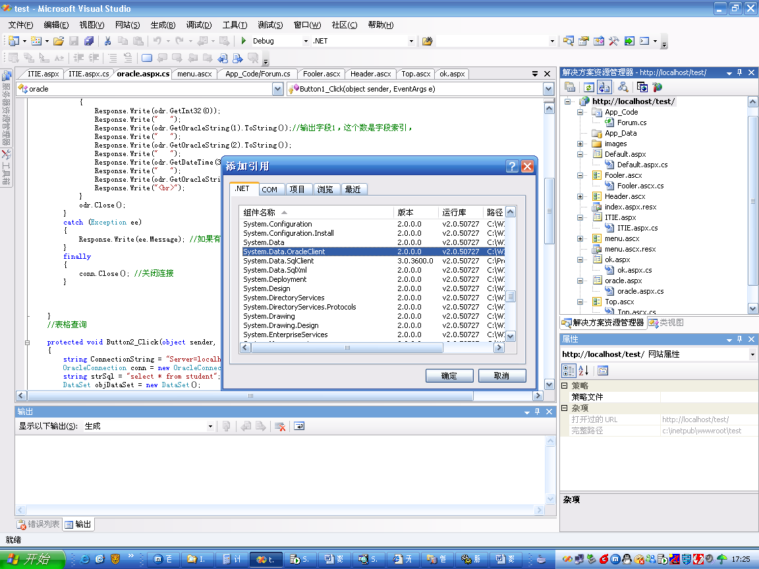

using System;
using System.Data;
using System.Configuration;
using System.Collections;
using System.Web;
using System.Web.Security;
using System.Web.UI;
using System.Web.UI.WebControls;
using System.Web.UI.WebControls.WebParts;
using System.Web.UI.HtmlControls;
using System.Data.OracleClient;

public partial class oracle : System.Web.UI.Page
{
protected void Page_Load(object sender, EventArgs e)
{

}

//简单查询
protected void Button1_Click(object sender, EventArgs e)
{

string ConnectionString = "Server=localhost;Data Source=test;user=system;password=manager;"; //写连接串
OracleConnection conn = new OracleConnection(ConnectionString);//创建一个新连接
try
{
conn.Open();
OracleCommand cmd = conn.CreateCommand();

cmd.CommandText = "select * from student";//在这儿写sql语句
OracleDataReader odr = cmd.ExecuteReader();//创建一个OracleDateReader对象
while (odr.Read())//读取数据，如果odr.Read()返回为false的话，就说明到记录集的尾部了
{
Response.Write(odr.GetInt32(0));
Response.Write(" ");
Response.Write(odr.GetOracleString(1).ToString());//输出字段1，这个数是字段索引，
Response.Write(" ");
Response.Write(odr.GetOracleString(2).ToString());
Response.Write(" ");
Response.Write(odr.GetDateTime(3).ToString());
Response.Write(" ");
Response.Write(odr.GetOracleString(4).ToString());
Response.Write("<br>");
}
odr.Close();
}
catch (Exception ee)
{

Response.Write(ee.Message); //如果有错误，输出错误信息
}
finally
{
conn.Close(); //关闭连接
}

}
//表格查询

protected void Button2_Click(object sender, EventArgs e)
{
string ConnectionString = "Server=localhost;Data Source=test;user=system;password=manager;"; //写连接串
OracleConnection conn = new OracleConnection(ConnectionString);//创建一个新连接
string strSql = "select * from student";
DataSet objDataSet = new DataSet();
OracleDataAdapter objDataAdapter = new OracleDataAdapter(strSql, conn);
objDataAdapter.Fill(objDataSet, "student");
DataView objDataView = new DataView(objDataSet.Tables["student"]);
GridView1.DataSource = objDataView;
GridView1.DataBind();

}
protected void Button3_Click(object sender, EventArgs e)
{
string ConnectionString = "Server=localhost;Data Source=test;user=system;password=manager;"; //写连接串
OracleConnection conn = new OracleConnection(ConnectionString);//创建一个新连接
try
{

conn.Open();
string temp = TextBox1.Text;
string temp1 = TextBox2.Text;

string strSql = "insert into student(sno,sname) values('"+temp+"', '"+temp1+"')";
OracleCommand cmd=new OracleCommand(strSql,conn);
cmd.ExecuteNonQuery();
prompt.Text = "新增用户成功，您可以在此页面继续添加新的用户！";

}
catch (Exception objE)
{
prompt.Text = objE.Message;//"新增用户失败！";
}
finally
{
conn.Close();
}

}
}

